E-COMMERCE ORDER MANAGEMENT DATABASE SYSTEM

MANAGE CUSTOMER PRODUCT ORDERS

1. Manage Customer Product Orders
The Manage Customer Product Orders operation is designed to create customer orders, add products to orders, calculate the total order amount, update order status, and display complete order details in the E-Commerce Order Management Database System.

2. View Available Customers and Products
The SELECT * FROM Customer; query displays all available customer records, while SELECT * FROM Product; displays all available product records. These queries help identify existing customers and products before creating an order.

3. Create a New Order
The INSERT INTO Orders ... SELECT query creates a new order with Order ID 5001, automatically selects an existing customer, records the current date, sets the initial total amount to 0.00, and assigns the status Pending.

4. Add Products to the Order
The INSERT INTO Order_Details ... SELECT query adds up to two existing products to Order ID 5001. It automatically selects product IDs and prices from the Product table and assigns quantities of 1 and 2 to the selected products, respectively.

5. Calculate Total Order Amount
The UPDATE Orders query calculates the total order amount by adding the subtotals of all products associated with Order ID 5001. Each product subtotal is calculated by multiplying its quantity by its price.

6. Update Order Status
The UPDATE Orders query changes the order status from Pending to Shipped after the order details and total amount have been updated.

7. Display Complete Order Details
The final SELECT query joins the Customer, Orders, Order_Details, and Product tables to display the customer name, order ID, order date, product name, quantity, price, subtotal, total order amount, and order status.

8. Screenshots
- Figure 1: Available Customers and Products

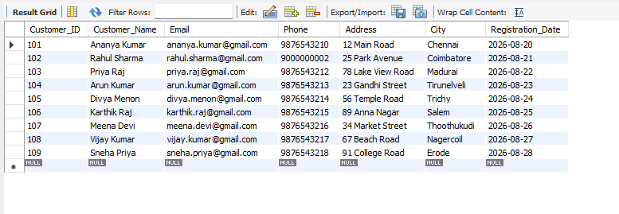

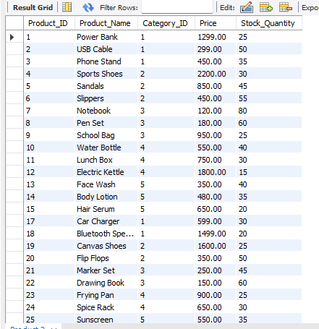

- Figure 2: New Order Creation
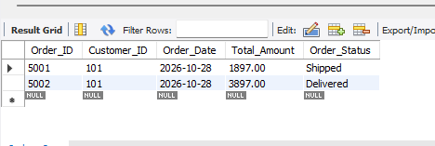
- Figure 3: Products Added to the Order
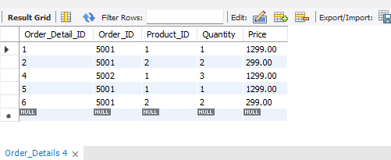
- Figure 4: Total Order Amount Calculation and Status Update
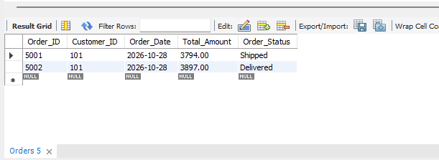
- Figure 5: Complete Customer Product Order Details
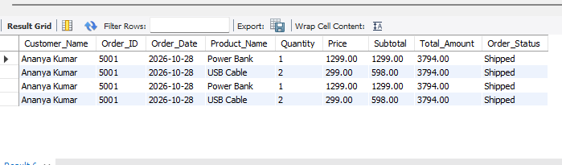

9. Conclusion
The Manage Customer Product Orders operation demonstrates how customer orders and associated products can be managed using SQL queries. It enables order creation, product selection, total amount calculation, status updates, and retrieval of complete order details. These operations help maintain organized and consistent order information in the E-Commerce Order Management Database System.

